What Is Halal

Halal is an Arabic word meaning lawful or permitted.

The opposite of Halal is Haram, which means unlawful or prohibited.

Halal and Haram are universal terms that apply to all facets of life. However, we will use these terms for this activity in relation to food products, meat products, cosmetics, personal care products, food ingredients and food contact materials.

It is the responsibility of every Muslim to eat pure (Halal) foods. Foods that are certified as Halal have the following logo on their packaging or label:

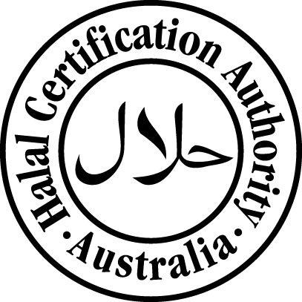
All foods are considered Halal except the following, which are Haram:
- Swine/pork and its by-products
- Animals improperly slaughtered or dead before slaughtering
- Animals killed in the name of anyone other than Allah (God)
- Alcohol and intoxicants
- Carnivorous animals, birds of prey and land animals without external ears
- Blood and blood by-products
- Foods contaminated with any of the above products
Products made from the following substances are considered to be Halal unless containing or coming into contact with a Haram substance:
- All plants and their products
- Certified Halal meat, poultry, game birds and animals
- All water creatures, fish, crustaceans and molluscs
- Egg from acceptable birds only
- Rennet from certified Halal slaughtered calves
- Non-animal rennet
- Gelatin produced from certified Halal beef skins and/or bones
- Animal ingredients certified Halal
While many things are clearly Halal or clearly Haram, there are some things which are not clear. These items are considered questionable or suspect and more information is needed to categorise them as Halal or Haram. Such items are often referred to as Mashbooh, which means doubtful or questionable. Foods containing ingredients such as gelatin, enzymes, emulsifiers, etc. are questionable because the origin of these ingredients is not known.

